**GIT desktop download/setup**

1. Download git desktop from the below location. <https://desktop.github.com/>

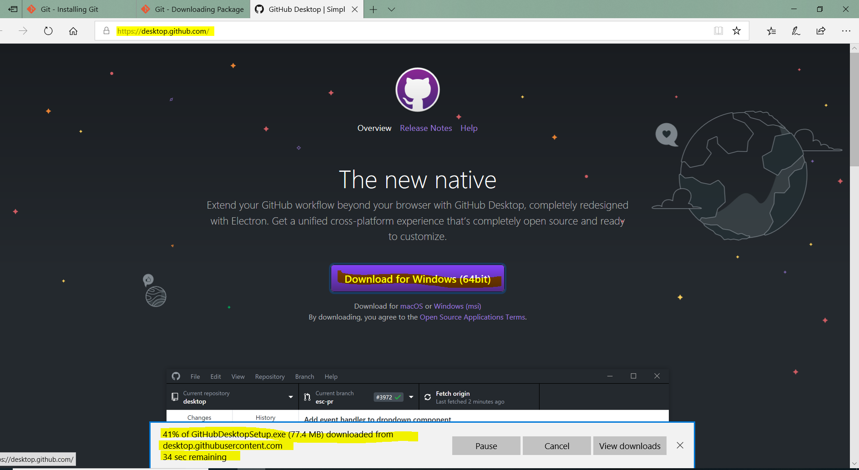

1. After download will complete you will find some files shown below.

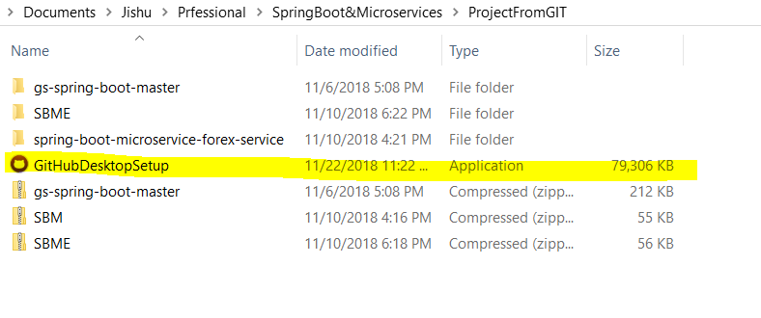

1. Double click on the icon.

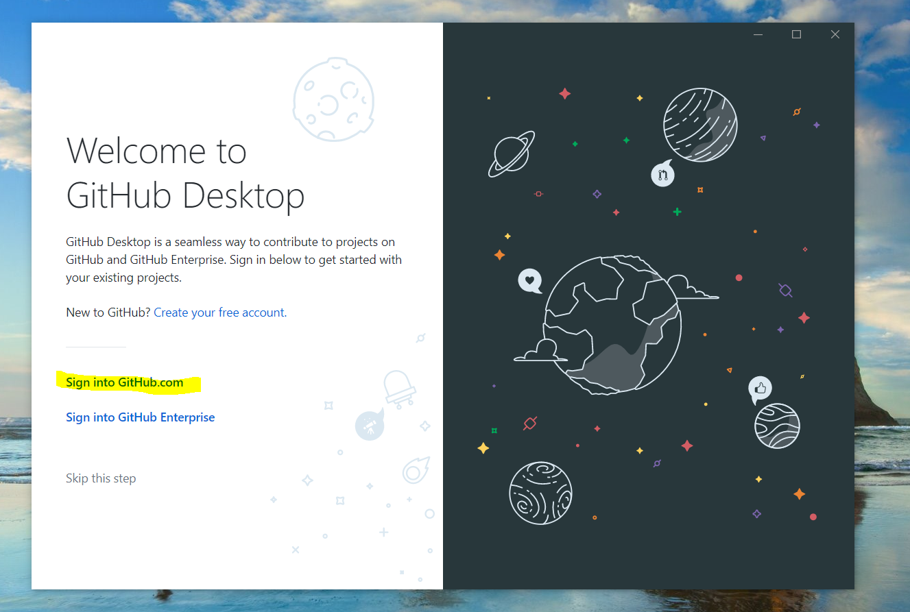

1. Now Click on Sign into GitHub.com. Required an id and password for the same. Better do it before installing.

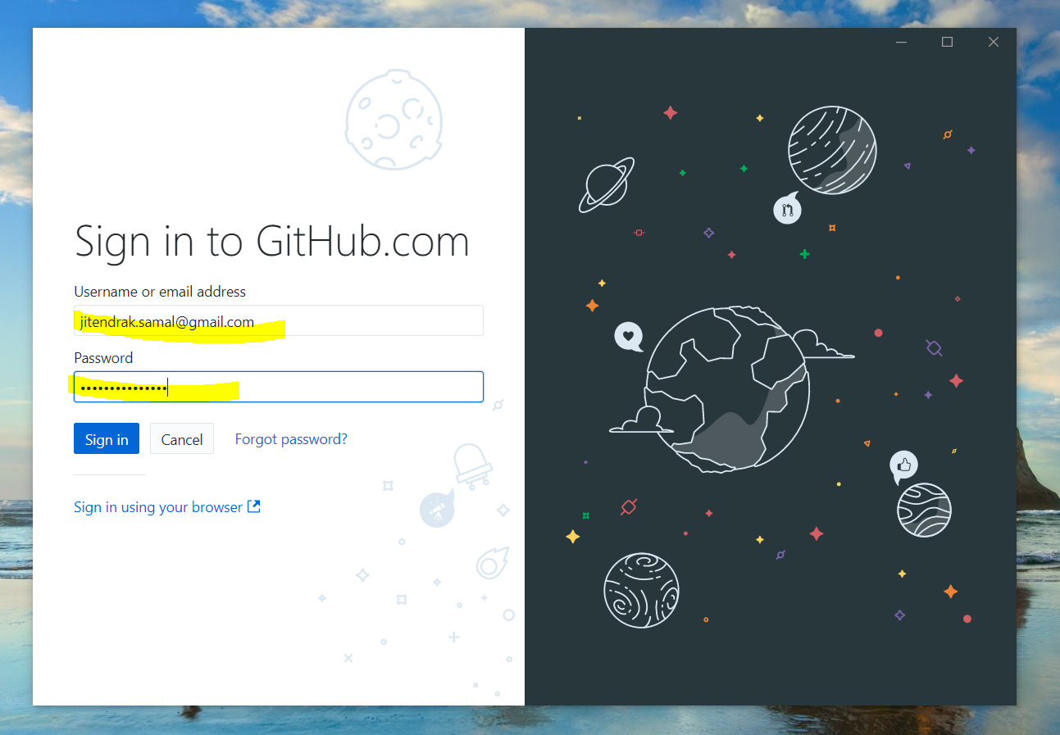

1. After providing id and password click on continue.

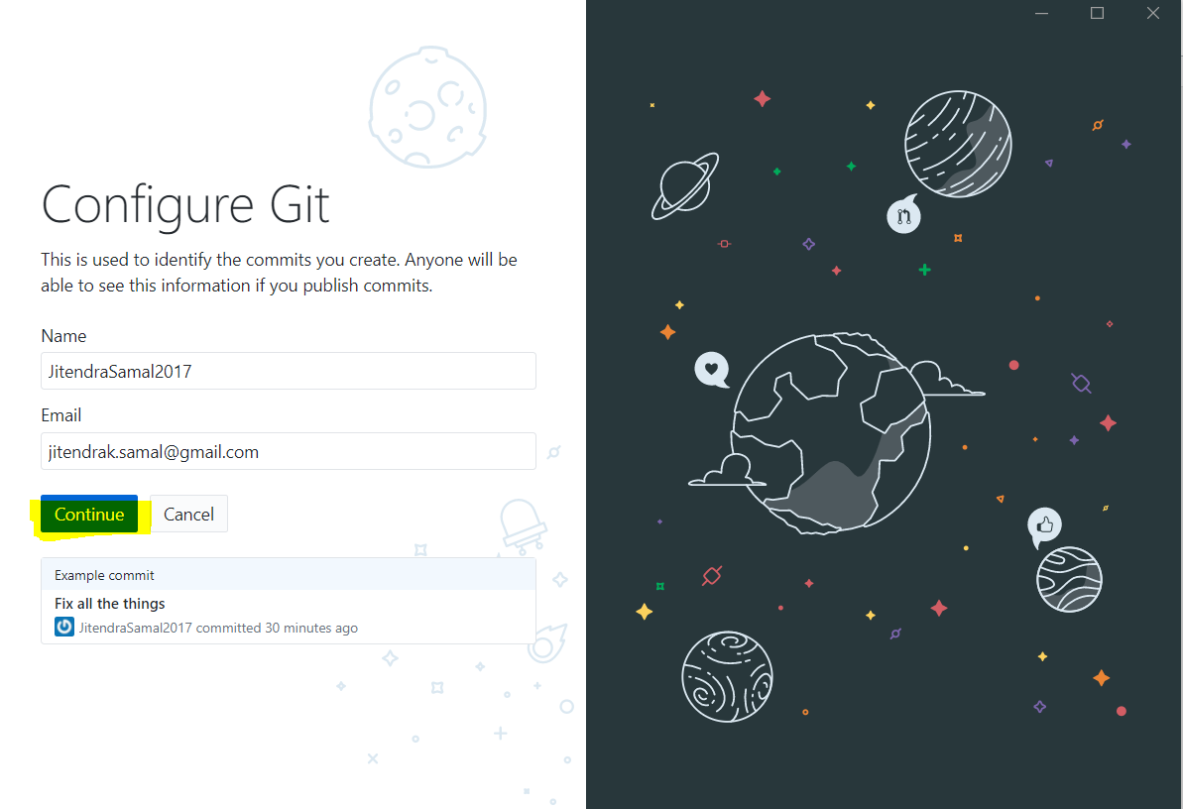

1. Follow the instructions.

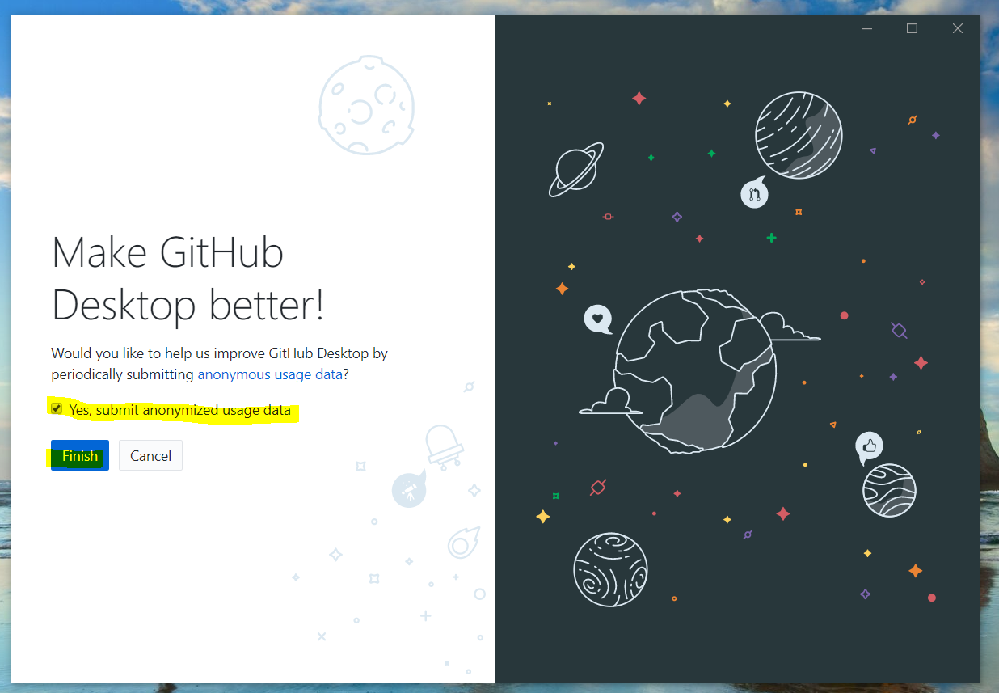

1. Follow the instructions.

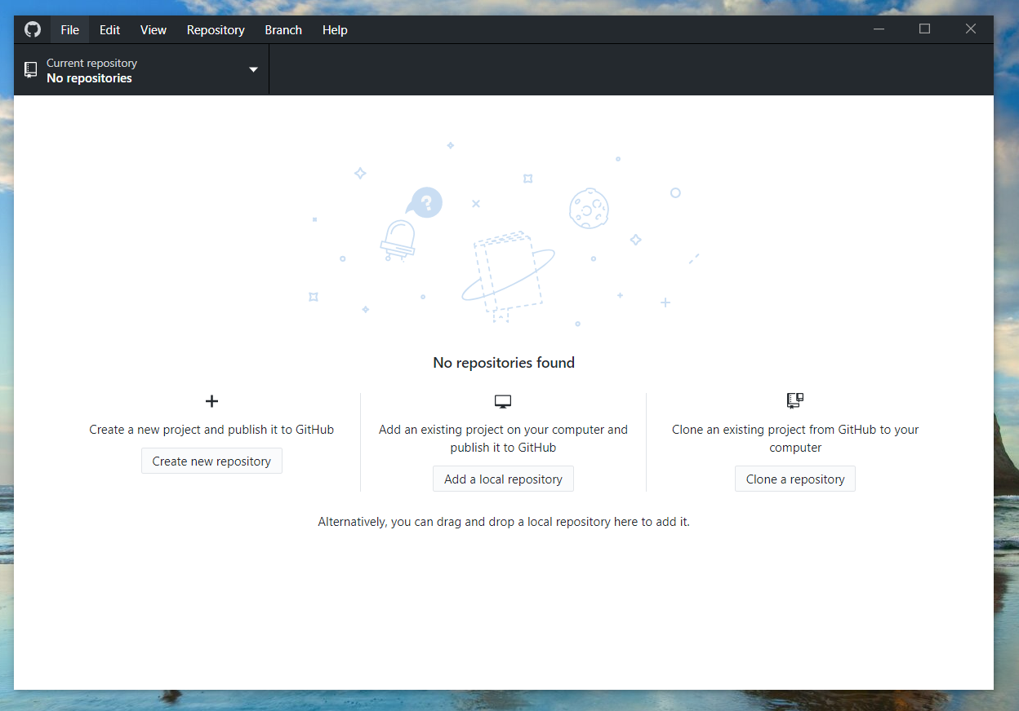

1. End of installation you will see Git Hub icon shown below in your desktop.

